1. Check the parts in your box

CPE SET | 1
DC 48V @ 400mA PoE Power Adapter | 1
Host Clamps | 2
Detachable AC Power Cord | 1
CD user manual | 1

2. Hot to fix the CPE on the Pole (1”- 1.5”)
(For better water resistance please wrap the RJ45 connector)
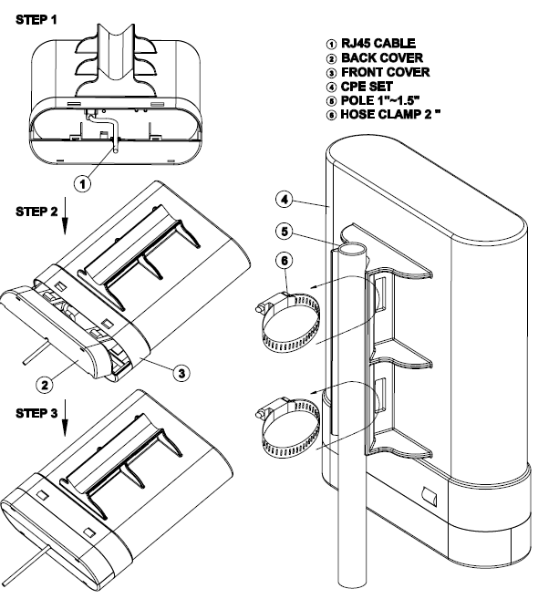

3. PoE connection

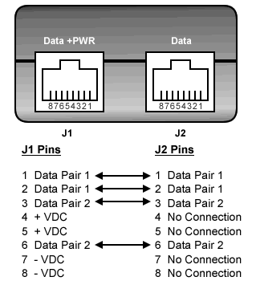
1. Connect (Data + PWR) RJ45 Jack to CPE RJ45 Jack with good quality Ethernet cable. (Up to 100 M maximum)
2. Connect (Data) Jack to PC or Switch Hub LAN port.
3. Plug the AC power Cordially,

4. CPE configuration

The WLAN Broadband Router is delivered with the following factory default parameters on the Ethernet LAN interfaces.

Default IP Address: 192.168.1.254
Default IP subnet mask: 255.255.255.0
WEB login User Name: <empty>
WEB login Password: <empty>

The device has three operation modes (Gateway/Bridge/WISP).
The default IP addresses for the device are 192.168.1.254, so you need to make sure the IP address of your PC is in the same subnet as the device, such as 192.168.1.X.
It will take about 55 seconds to complete the boot up sequence after power on from PoE.
5. Wireless ISP mode to connect ISP AP

The NAT (Network Address Translation) is enabled and PC’s RJ45 ports share the same IP to ISP through wireless LAN. You must set the wireless to client mode first and connect to the ISP AP in Site-Survey page. The connection application is most valuable for this CPE to access internet freely.

